**Taints** and **Tolerations** work together to control which nodes can run specific pods. This mechanism helps ensure that certain pods are only scheduled on designated nodes, or conversely, that certain nodes repel specific pods.

Let’s say we have 3 node, node 1 should contains the pod which only works on AI and remaining 2 nodes will be normal node.

Now we created a normal POD this POD won’t create on node 1 because it is specified that node 1 should work only for AI related work, so POD get rejected and move to other nodes.

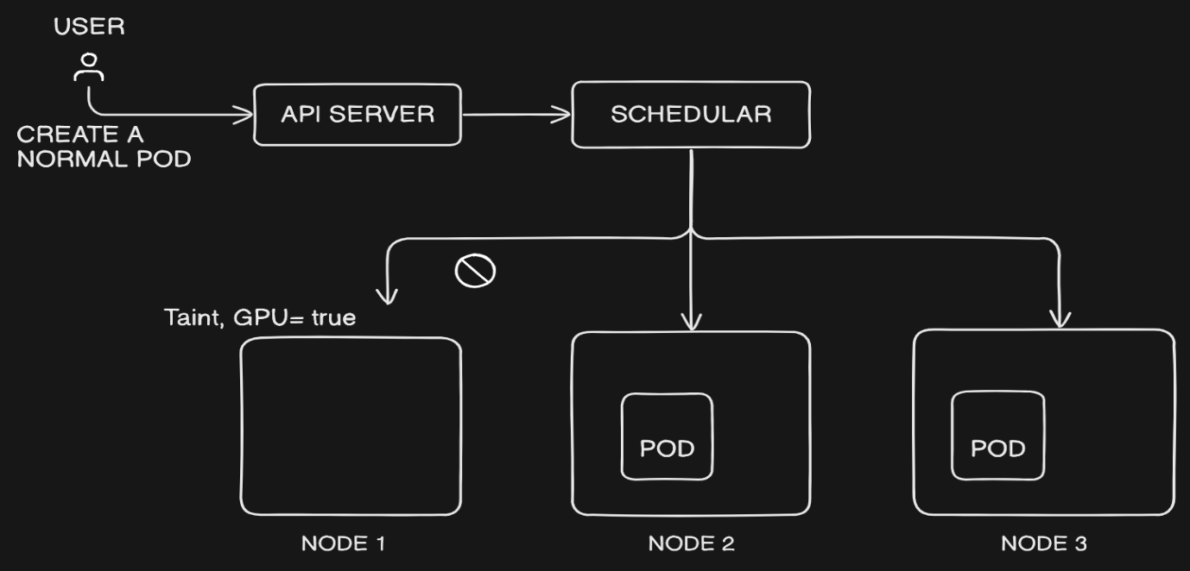

When POD is specified by toleration then it will check node 1 is accepting it or not. If it accepts it will be created on node 1.

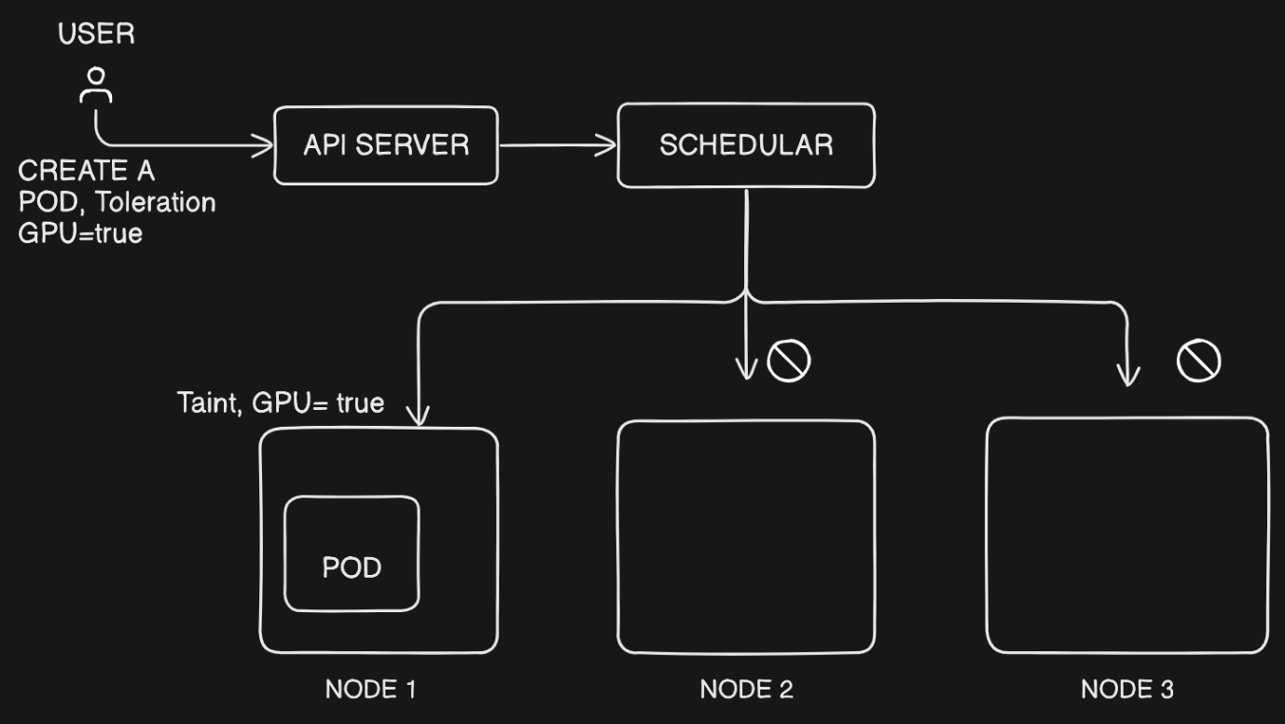

Taint we do it on NODE, Toleration we do it on POD

Taints consist of three parts:

1. **Key**: An identifier for the taint (e.g., key=value:effect).
2. **Value**: An optional value associated with the key.
3. **Effect**: Defines the action to be taken when a pod doesn't tolerate the taint.
   * **NoSchedule**: it will work on newer PODS
   * **preferNOSchedule**: Kubernetes avoids scheduling pods that don't tolerate the taint, but it's not guaranteed.
   * **noExecute**: on existing or newer PODS

why we use Taint?

* If we have specialized node for to run specific type of work load
* Control plane has taint on default because only control plane component and system components should be scheduled on control plane node that why It automatically added taint on the node

